**SMART AGRICULTURE SYSTEM BASED ON IOT**

## By

### Shubhika Gupta

A project report submitted to

#### The SmartBridge

in partial fulfillment of the requirements for the internship title

# [llSPS-INT-2924-Smart-Agriculture-system-based-on-IoT](https://github.com/SmartPracticeschool/llSPS-INT-2924-Smart-Agriculture-system-based-on-IoT)

Top of Form

**TABLE OF CONTENTS**

|  |  |  |  |
| --- | --- | --- | --- |
| SERIAL NO. | NAME OF CONTENT | PAGE NO. | REMARK |
|  |  |  |  |
| 1. | *INTRODUCTION* | 3 |  |
| 1.1 | *Overview* | 3 |  |
| 1.2 | *Purpose* | 3 |  |
| 2. | *Literature Survey* | 4 |  |
| 2.1 | *Existing problem* | 4 |  |
| 2.2 | Proposed Solution | 5 |  |
| 3. | *Theoretical Analysis* | 9 |  |
| 3.1 | *Block Diagram* | 10 |  |
| 3.2 | *Hardware/Software Designing* | 10 |  |
| 4. | *Experimental Investigations* | 11 |  |
| 5. | *FlowChart* | 12 |  |
| 6. | *Result* | 14 |  |
| 7. | *Advantages/Disadvantages* | 16 |  |
| 8. | *Applications* | 17 |  |
| 9. | *Conclusion* | 19 |  |
| 10. | *Future Scope* | 20 |  |
| 11. | *Bibliography* | 20 |  |
|  |  |  |  |

**INTRODUCTION**

**Project Description**

•Smart Agriculture System based on IOT can monitor soil moisture and climatic conditions to grow and yield a good crop.

•The farmer can also get the real-time weather forecasting data by using external platforms like Open Weather API.

•Based on all the parameters he can water his crop by controlling the motors using the mobile application.

•Here we are using the Online IOT simulator for getting the Temperature, Humidity and Soil Moisture values

**Purpose**

The global population is predicted to touch 9.6 billion by 2050 – this poses a big problem for the agriculture industry. Despite combating challenges like extreme weather conditions, rising climate change, and farming’s environmental impact, the demand for more food has to be met. To meet these increasing needs, agriculture has to turn to new technology. New smart farming applications based on IOT technologies will enable the agriculture industry to reduce waste and enhance productivity from optimizing fertilizer use to increasing the efficiency of farm vehicles’ routes.

**So, what is smart farming?** Smart farming is a capital-intensive and hi-tech system of growing food cleanly and sustainable for the masses. It is the application of modern ICT (Information and Communication Technologies) into agriculture.

In IOT-based smart farming, a system is built for monitoring the crop field with the help of sensors (light, humidity, temperature, soil moisture, etc.) and automating the irrigation system. The farmers can monitor the field conditions from anywhere. IOT-based smart farming is highly efficient when compared with the conventional approach. The applications of IOT-based smart farming not only target conventional, large farming operations, but could also be new levers to uplift other growing or common trends in agricultural like organic farming, family farming (complex or small spaces, particular cattle and/or cultures, preservation of particular or high-quality varieties, etc.), and enhance highly transparent farming.

**LITERATURE SURVEY**

**Existing Solutions:**

|  |  |
| --- | --- |
| Application Name | Description |
| Crop Water Management | In order to perform agriculture activities in efficient manner, adequate water is essential. Agriculture IoT is integrated with Web Map Service (WMS) and Sensor Observation Service (SOS) to ensure proper water management for irrigation and in turn reduces water wastage. |
| Precision Agriculture | High accuracy is required in terms of weather information which reduces the chances of crop damage. Agriculture IoT ensures timely delivery of real time data in terms of weather forecasting, quality of soil, cost of labor and much more to farmers. |
| Integrated Pest Management or Control (IPM/C) | Agriculture IoT systems assures farmers with accurate environmental data via proper live data monitoring of temperature, moisture, plant growth and level of pests so that proper care can be taken during production. |
| Food Production & Safety | Agriculture IoT system accurately monitors various parameters like warehouse temperature, shipping transportation management system and also integrates cloud based recording systems. |
| Other Projects Implemented Till Date | 1. The Phenonet Project by Open IoT  2. CLAAS Equipment  3. Precisionhawk’s UAV Sensor Platform  4. Cleangrow’s Carbon Nanotube Probe  5. Temputech’s Wireless Sensor Monitoring. |

**PROPOSED SYSTEM:**

-Install node red locally

-Create IBM account and explore IBM platform

-Connect IOT Simulator to IBM Watson IOT Platform

-Configure node-red to get data from IBM IOT platform and Open Weather Api

-Configure nodes to display weather parameter

-Configure nodes for creating buttons

-Python code to subscribe ibmiotf platform

**Pre-requisites: (Steps to work)**

1. Create IBM cloud

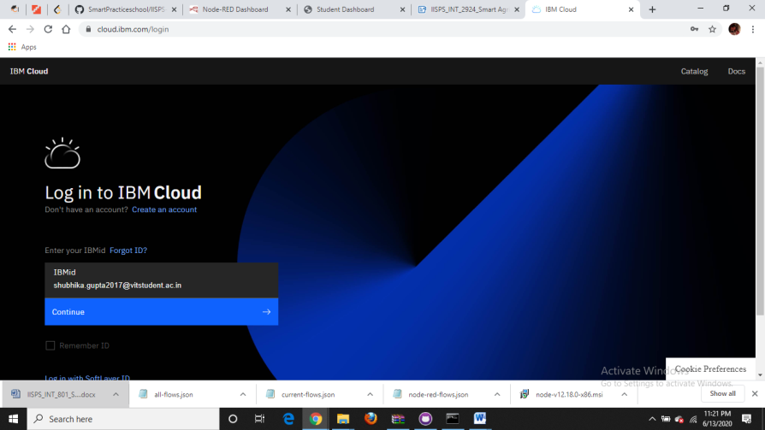

1. Create IBM Watson platform

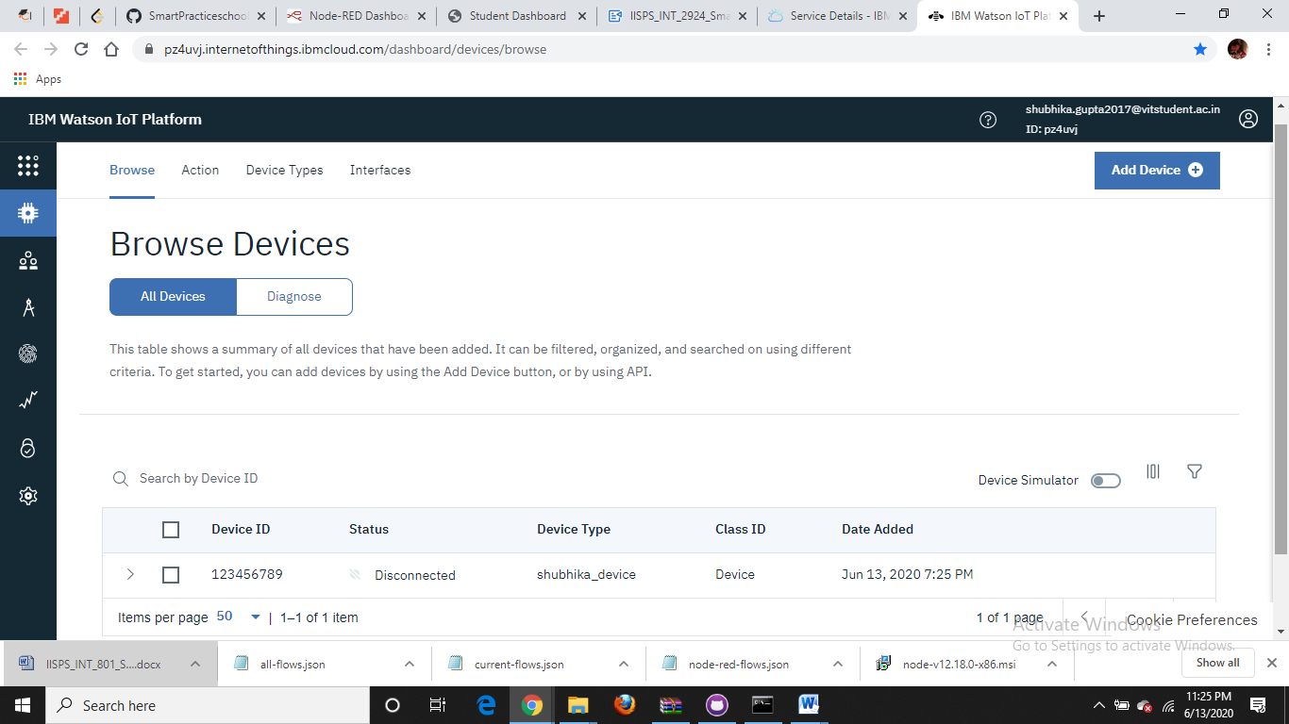

1. Get the organisational id

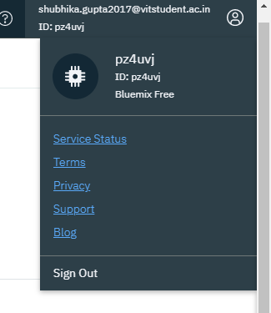

1. Create Device in IBM Watson platform (Device Drilldown)

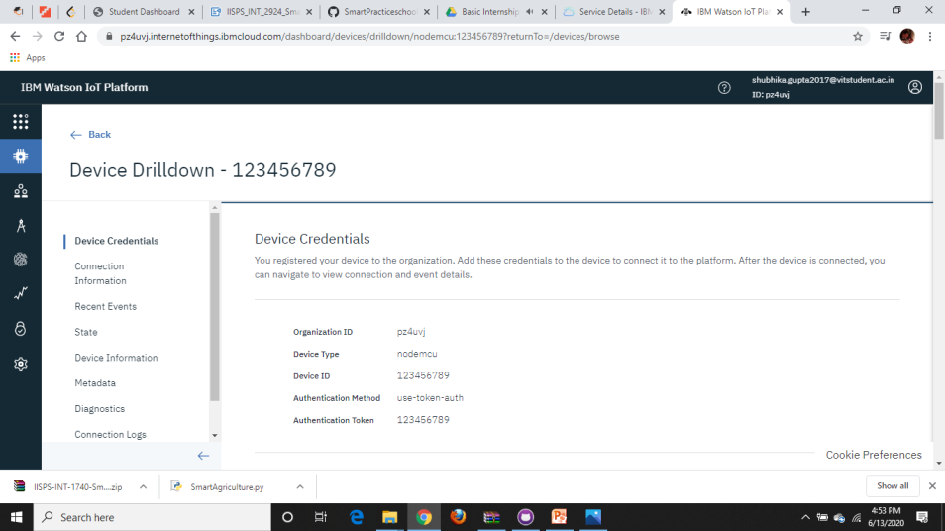

1. Connect IOT sensor simulator

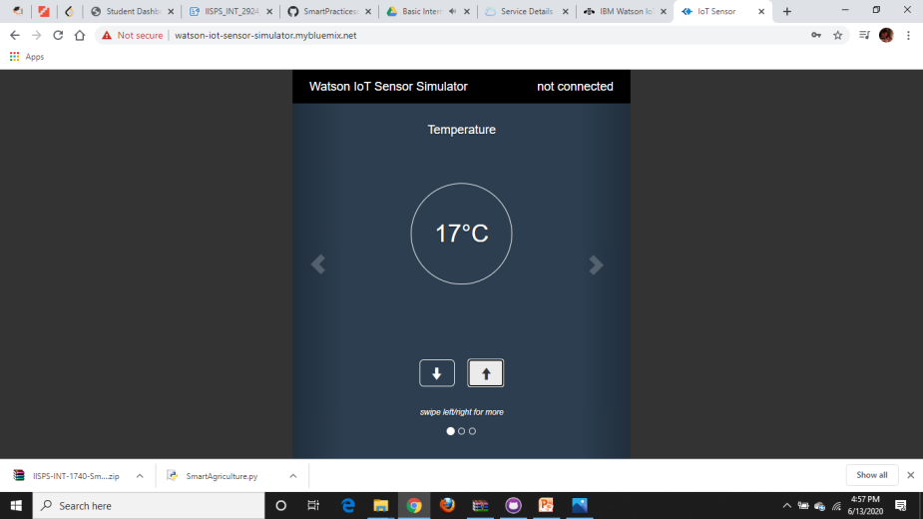

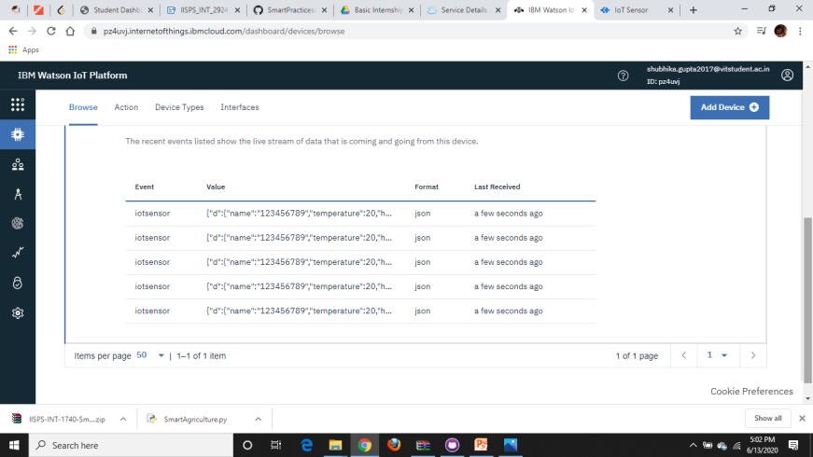

1. Install Node-red

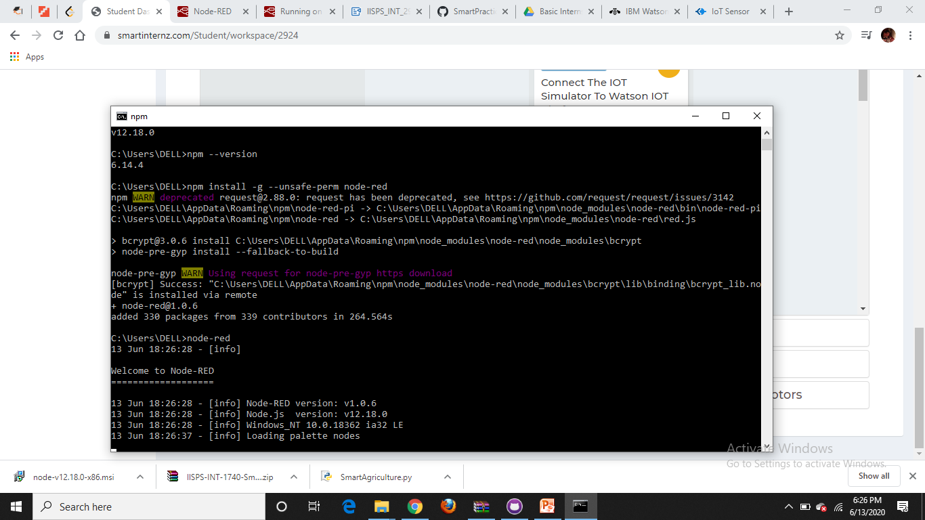

1. Install python 3.8.3 IDE
2. Install npm and node js (apparently)
3. run node-red from cmd prompt
4. you can recieve the server <http://127.0.0.1:1880/>

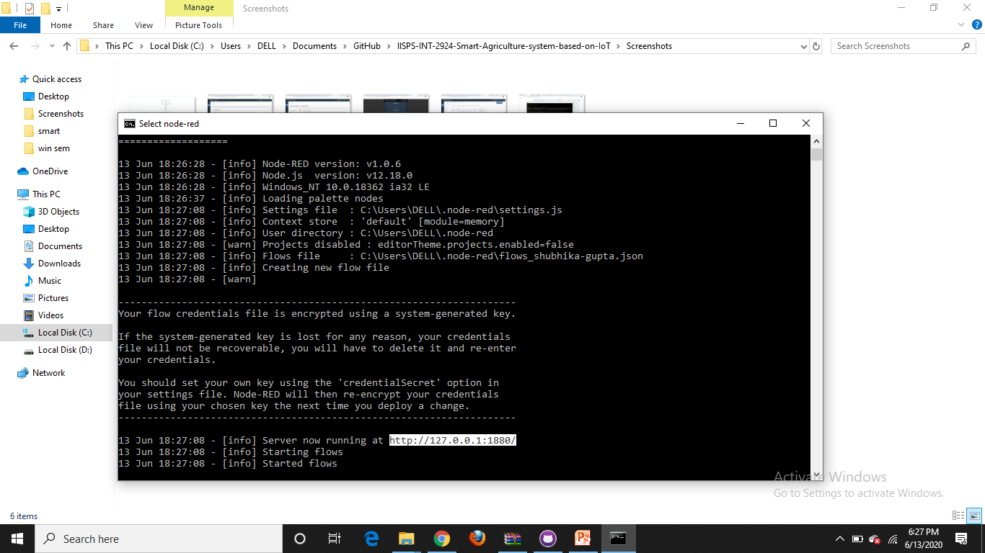

1. We can see nodes in node red platform

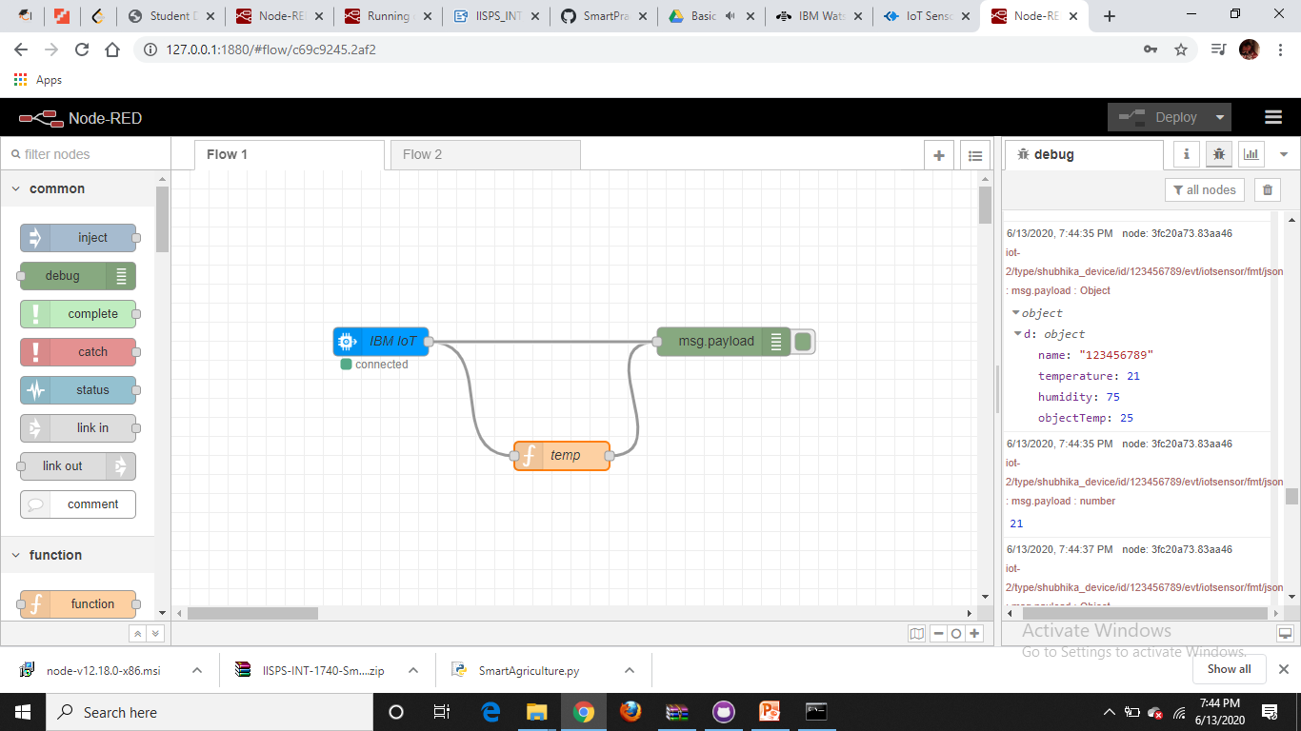

1. Install necessary palletes from Manage Palette and connect the node-red platform with the iot simulator and ibm watsom platform
2. Create the node-red flow diagram using that nodes available
3. You can see the gauge by clicking [http://127.0.0.1:1880/ui/](http://127.0.0.1:1880/ui/#!/0?socketid=H4l9_ePAiFirwulbAAAA)

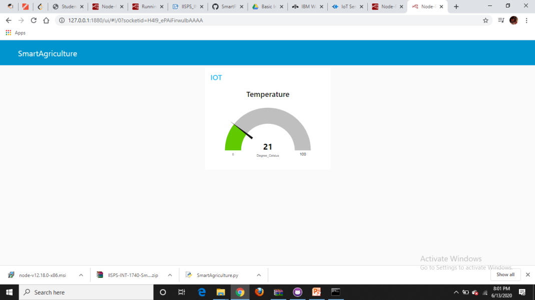

**THEORETICAL ANALYSIS:**

* **IBM Cloud** is a set of [cloud computing](https://en.wikipedia.org/wiki/Cloud_computing) services for business offered by the information technology company [IBM](https://en.wikipedia.org/wiki/IBM). Here , IBM platform acts as an interface to control the electronic devices in real time through Watson IoT platform.
* **The Watson IOT platform** is used when the projects contain hardware such as sensors , electronic devices . It acts as an interface between devices and IBM Cloud by retrieving data from the devices and sending it to cloud and vice-versa.
* The simulated data is sent from **IBM IOT simulator** to IBM Watson cloud platform and then presented in **web interface using http/mqtt web protocols**.
* To know the real time data of any agricultural farm, we use **Open weather API** (Application Program Interface ), which has some predefined APIs.
* Once the data is received , it is sent to the cloud via **Node-red platform** .
* The data is monitored continuously (here temperature , humidity and soil temperature) from a web interface .
* In case of watering crops **motor** can be turned on or off through the web interface controlled through internet.

**BLOCK DIAGRAM:**

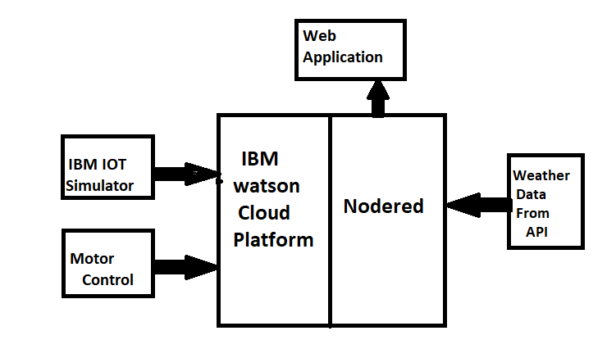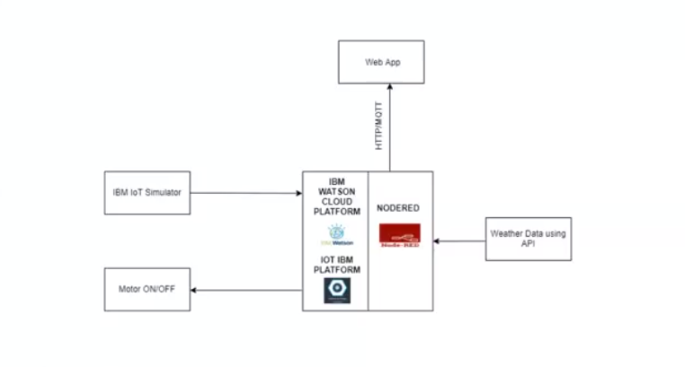

**Software Designing:**

**3. 1 IBM Cloud platform**

The IBM cloud platform combines platform as a service (PaaS) with infrastructure as a service (IaaS) to provide an integrated experience. The platform scales and supports both small development teams and organizations, and large enterprise businesses. Globally deployed across data centres around the world, the solution you build on IBM Cloud™ spins up fast and performs reliably in a tested and supported environment you can trust.

The platform is built to support your needs whether it is working only in the public cloud or taking advantage of a multi cloud deployment model.

**3.1.a. Node-RED**

Node-RED is a [flow-based](https://en.wikipedia.org/wiki/Flow-based_programming) development tool for [visual programming](https://en.wikipedia.org/wiki/Visual_programming_language) developed originally by [IBM](https://en.wikipedia.org/wiki/IBM) for wiring together hardware devices, [APIs](https://en.wikipedia.org/wiki/Application_programming_interface) and [online services](https://en.wikipedia.org/wiki/Online_services) as part of the [Internet of Things](https://en.wikipedia.org/wiki/Internet_of_Things).

Node-RED provides a [web browser](https://en.wikipedia.org/wiki/Web_browser)-based flow editor, which can be used to create [JavaScript](https://en.wikipedia.org/wiki/JavaScript) functions. Elements of applications can be saved or shared for re-use. The runtime is built on [Node.js](https://en.wikipedia.org/wiki/Node.js). The flows created in Node-RED are stored using [JSON](https://en.wikipedia.org/wiki/JSON). Since version 0.14, [MQTT](https://en.wikipedia.org/wiki/MQTT) nodes can make properly configured [TLS](https://en.wikipedia.org/wiki/Transport_Layer_Security) connections.

**3.1.b. IBM Watson IoT Platform**

Watson is the open, multi cloud platform that lets you automate the AI lifecycle. Build powerful models from scratch, or speed time-to-value with pre-built enterprise apps.

It allows secure, analyse and manage IoT data.

**3.2 Python IDE**

IDLE (short for Integrated DeveLopment Environment or Integrated Development and Learning Environment) is an [integrated development environment](https://en.wikipedia.org/wiki/Integrated_development_environment) for [Python](https://en.wikipedia.org/wiki/Python_(programming_language)), which has been bundled with the default implementation of the language since 1.5.2b1. It is packaged as an optional part of the Python packaging with many [Linux distributions](https://en.wikipedia.org/wiki/Linux_distributions). It is completely written in Python and the [Tkinter](https://en.wikipedia.org/wiki/Tkinter) GUI toolkit ([wrapper](https://en.wikipedia.org/wiki/Wrapper_function) functions for [Tcl](https://en.wikipedia.org/wiki/Tcl)/[Tk](https://en.wikipedia.org/wiki/Tk_(framework))).

**Experimental Investigations:**

1. To retrieve data i.e temperature, humidity etc. , add a device in IBM Watson IoT platform
2. For connecting IBM cloud and node -RED we use API key which is generated in IBM Watson
3. Connect the device to the simulator using the credentials such as device type, organization ID, authentication token etc.

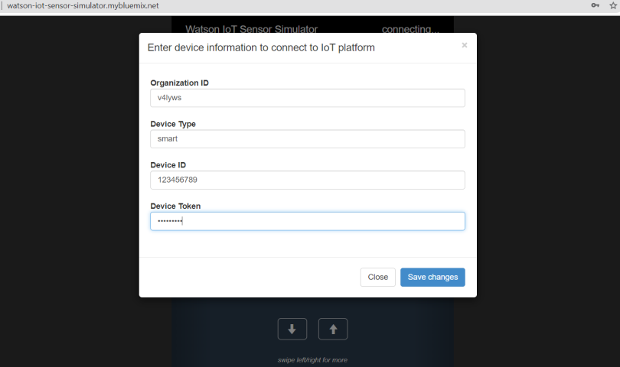

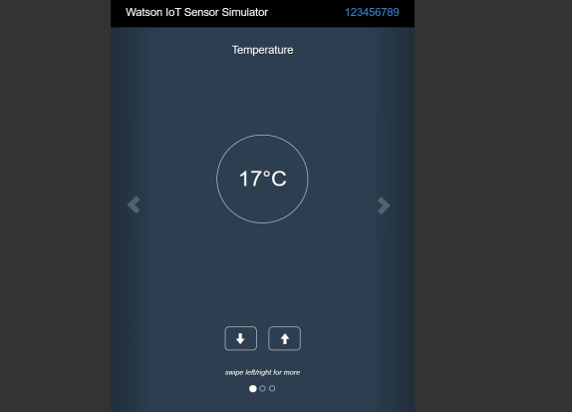

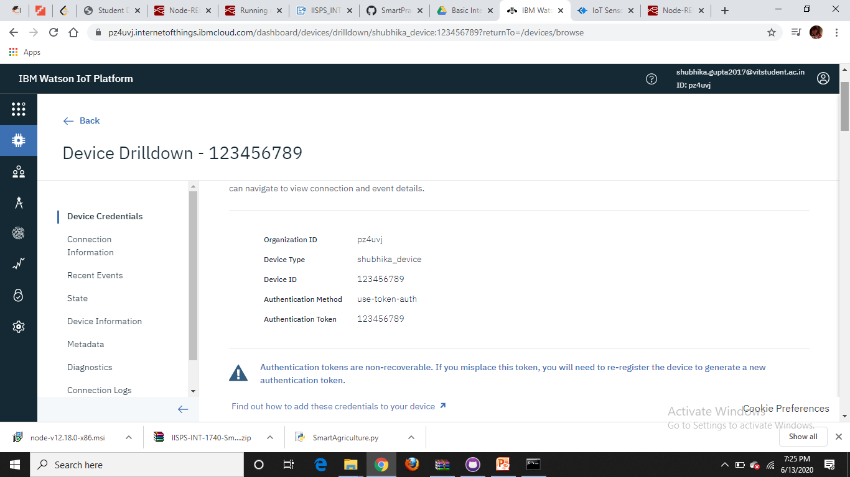

1. Add the API key in IBM IoT input node in nod -RED

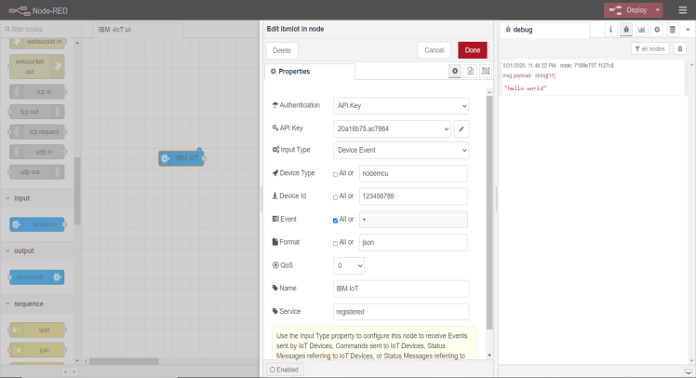

1. Use open weather API to get details of climatic conditions of any city . (Here Kanpur) and the deploy the whole flow.

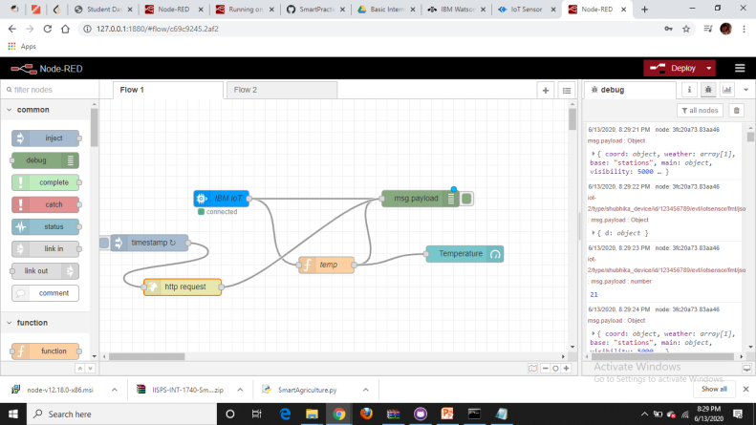

9. Add http request and a gauge to view the temperature using open weather API in a web interface

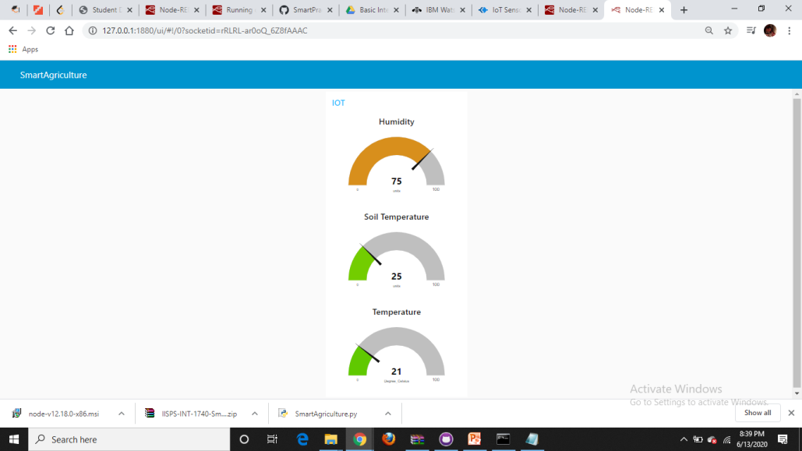

10 . Add motor on and motor off button to the flow including IBM output node configured with the same API key

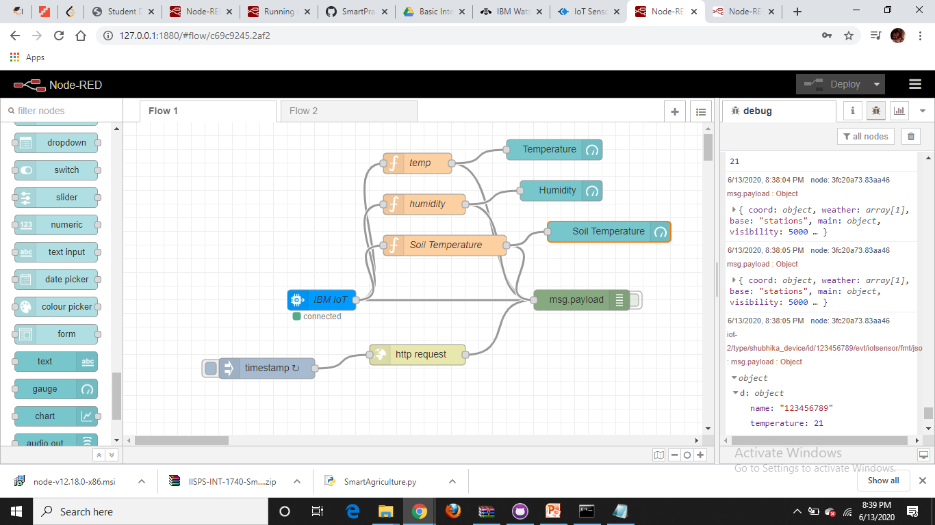

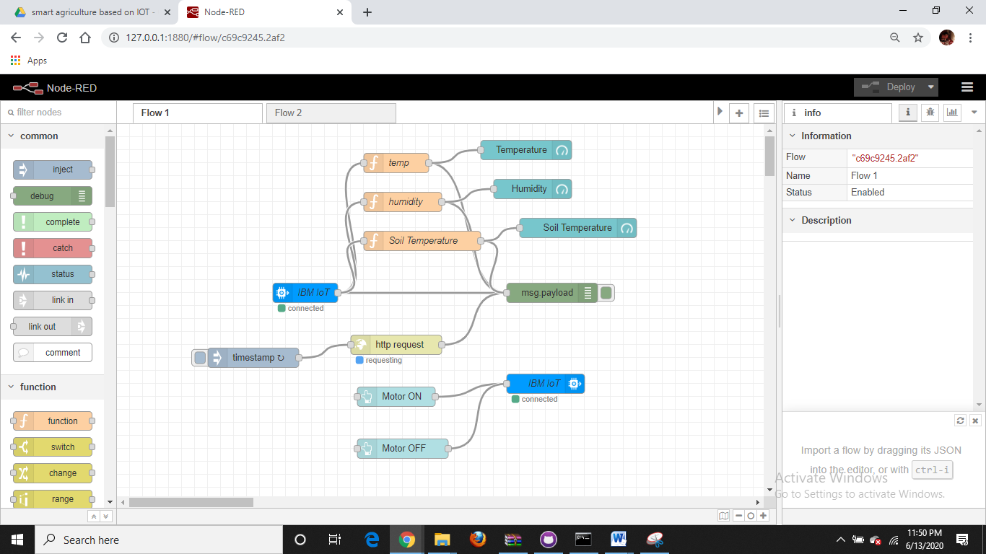

11. Write python code, import ibmiotf to python by installing it in system (pip install ibmiotf command in command prompt) and run the code.

**RESULT:**

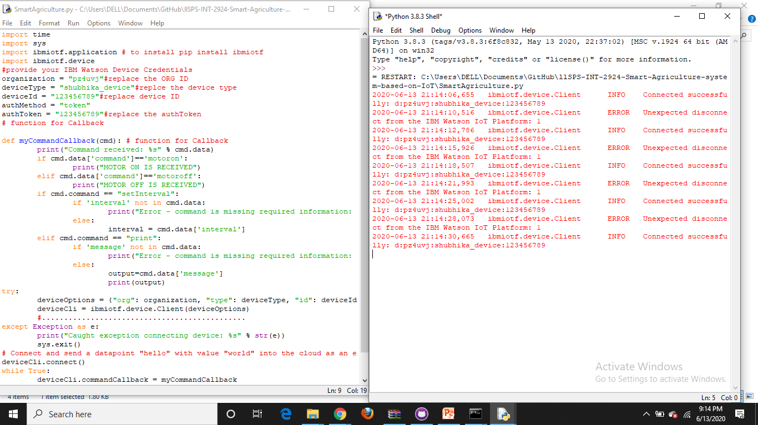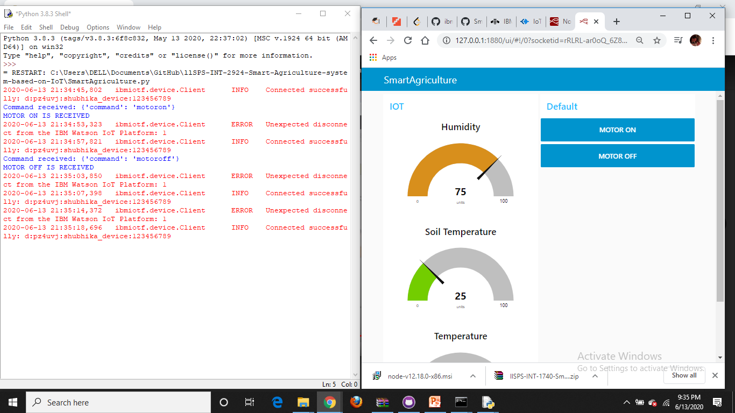

We can also analyze the obtained data using cards in IBM Watson IoT platform as shown in figure.

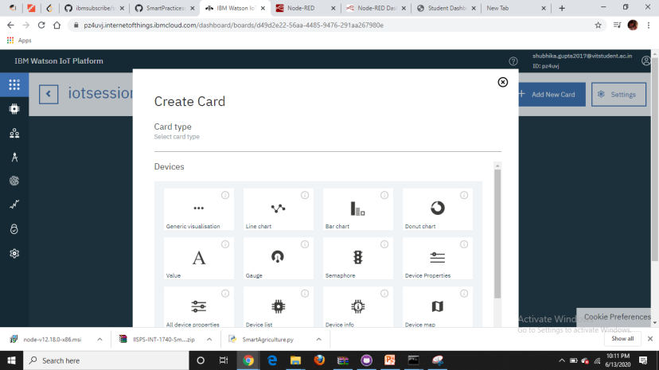

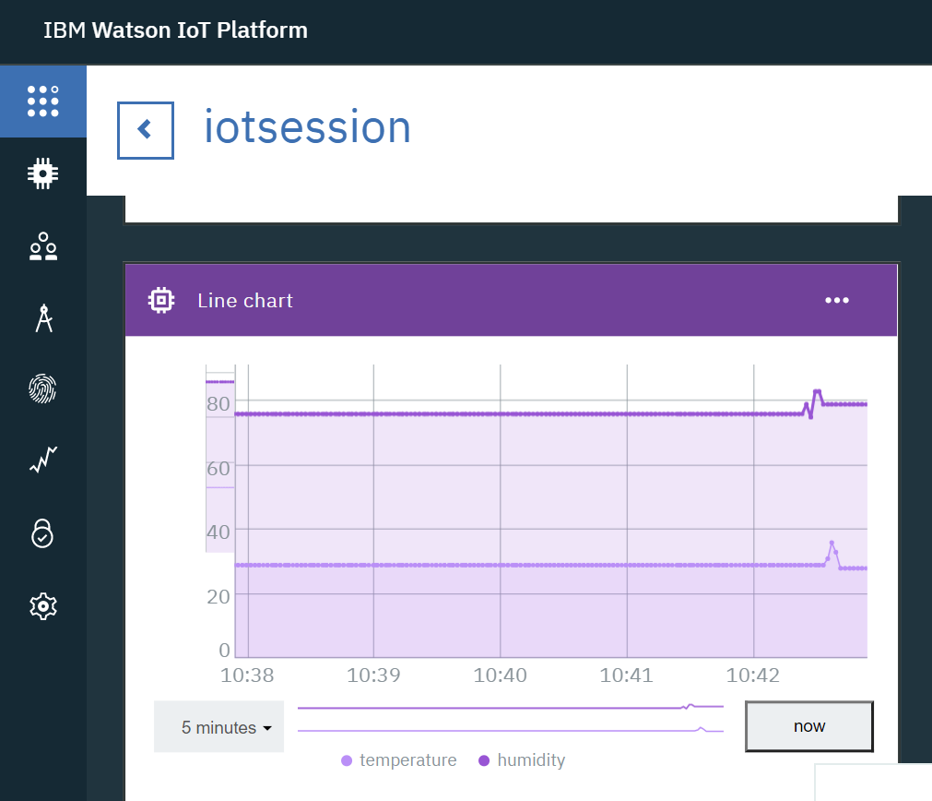

We can also analyse the data randomly (here distance and weight) by sending the simulated data into the device made as shown in figure

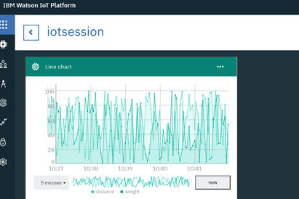

**ADVANTAGES:**

#### Increased Production

Optimized crop treatment such as accurate planting, watering, pesticide application and harvesting directly affects production rates.

#### Water Conservation

Weather predictions and soil moisture sensors allow for water use only when and where needed.

#### Real-Time Data and Production Insight

Farmers can visualize production levels, soil moisture, sunlight intensity and more in real time and remotely to accelerate decision making process.

#### Lowered Operation Costs

Automating processes in planting, treatment and harvesting can reduce resource consumption, human error and overall cost.

#### Increased Quality of Production

Analyzing production quality and results in correlation to treatment can teach farmers to adjust processes to increase quality of the product.

#### Accurate Farm and Field Evaluation

Accurately tracking production rates by field over time allows for detailed predicting of future crop yield and value of a farm.

#### Improved Livestock Farming

Sensors and machines can be used to detect reproduction and health events earlier in animals. Geofencing location tracking can also improve livestock monitoring and management.

#### Reduced Environmental Footprint

All conservation efforts such as water usage and increased production per land unit directly affect the environmental footprint positively.

#### Remote Monitoring

Local and commercial farmers can monitor multiple fields in multiple locations around the globe from an internet connection. Decisions can be made in real-time and from anywhere.

#### Equipment Monitoring

Farming equipment can be monitored and maintained according to production rates, labor effectiveness and failure prediction.

**DISADVANTAGES:**

➨The smart agriculture needs availability of internet continuously. Rural part of most of the developing countries do not fulfil this requirement. Moreover internet connection is slower.

➨The smart farming based equipments require farmers to understand and learn the use of technology. This is major challange in adopting smart agriculture farming at large scale across the countries.

**APPLICATIONS:**

1. Climate Conditions

Climate plays a very critical role for farming. And having improper knowledge about climate heavily deteriorates the quantity and quality of the crop production. But IoT solutions enable you to know the real-time weather conditions. Sensors are placed inside and outside of the agriculture fields. They collect data from the environment which is used to choose the right crops which can grow and sustain in the particular climatic conditions. The whole IoT ecosystem is made up of sensors that can detect real-time weather conditions like humidity, rainfall, temperature and more very accurately. There are numerous no. of sensors available to detect all these parameters and configure accordingly to suit your smart farming requirements. These sensors monitor the condition of the crops and the weather surrounding them. If any disturbing weather conditions are found, then an alert is send. What gets eliminated is the need of the physical presence during disturbing climatic conditions which eventually increases the productivity and help farmers to reap more agriculture benefits.

1. Precision Farming

Precision Agriculture/Precision Farming is one of the most famous applications of IoT in Agriculture. It makes the farming practice more precise and controlled by realizing smart farming applications such as livestock monitoring, vehicle tracking, field observation, and inventory monitoring. The goal of precision farming is to analyze the data, generated via sensors, to react accordingly. Precision Farming helps farmers to generate data with the help of sensors and analyze that information to take intelligent and quick decisions. There are numerous precision farming techniques like irrigation management, livestock management, vehicle tracking and many more which play a vital role in increasing the efficiency and effectiveness. With the help of Precision farming, you can analyze soil conditions and other related parameters to increase the operational efficiency. Not only this you can also detect the real-time working conditions of the connected devices to detect water and nutrient level.

1. Smart Greenhouse

To make our greenhouses smart, IoT has enabled weather stations to automatically adjust the climate conditions according to a particular set of instructions. Adoption of IoT in Greenhouses has eliminated the human intervention, thus making entire process cost-effective and increasing accuracy at the same time. For example, using solar-powered IoT sensors builds modern and inexpensive greenhouses. These sensors collect and transmit the real-time data which helps in monitoring the greenhouse state very precisely in real-time. With the help of the sensors, the water consumption and greenhouse state can be monitored via emails or SMS alerts. Automatic and smart irrigation is carried out with the help of IoT. These sensors help to provide information on the pressure, humidity, temperature and light levels.

1. Data Analytics

The conventional database system does not have enough storage for the data collected from the IoT sensors. Cloud based data storage and an end-to-end IoT Platform plays an important role in the smart agriculture system. These systems are estimated to play an important role such that better activities can be performed. In the IoT world, sensors are the primary source of collecting data on a large scale. The data is analyzed and transformed to meaningful information using analytics tools. The data analytics helps in the analysis of weather conditions, livestock conditions, and crop conditions. The data collected leverages the technological innovations and thus making better decisions. With the help of the IoT devices, you can know the real-time status of the crops by capturing the data from sensors. Using predictive analytics, you can get an insight to make better decisions related to harvesting. The trend analysis helps the farmers to know upcoming weather conditions and harvesting of crops. IoT in the Agriculture Industry has helped the farmers to maintain the quality of crops and fertility of the land, thus enhancing the product volume and quality.

1. Agricultural Drones

Technological advancements has almost revolutionized the agricultural operations and the introduction of agricultural drones is the trending disruption. The Ground and Aerial drones are used for assessment of crop health, crop monitoring, planting, crop spraying, and field analysis. With proper strategy and planning based on real-time data, drone technology has given a high rise and makeover to the agriculture industry. Drones with thermal or multispectral sensors identify the areas that require changes in irrigation. Once the crops start growing, sensors indicate their health and calculate their vegetation index. Eventually smart drones have reduced the environmental impact. The results have been such that there has been a massive reduction and much lower chemical reaching the groundwater.

**CONCLUSION:**

IoT enabled agriculture has helped implement modern technological solutions to time tested knowledge. This has helped bridge the gap between production and quality and quantity yield. Data Ingested by obtaining and importing information from the multiple sensors for real time use or storage in a database ensures swift action and less damage to the crops. With seamless end to end intelligent operations and improved business process execution, produce gets processed faster and reaches supermarkets in fastest time possible.

**FUTURE SCOPE:**

IOT device can be helpful in many ways and future implementation can be interesting and insightful.

**BIBLIOGRAPHY:**

<https://drive.google.com/drive/folders/1L1O6SnZgzpjQWIhOqeTY7sWuJtjs1XtN?usp=sharing>

<https://www.biz4intellia.com/blog/5-applications-of-iot-in-agriculture/>

<https://www.rfwireless-world.com/Terminology/Advantages-and-Disadvantages-of-Smart-Agriculture-Farming.html>